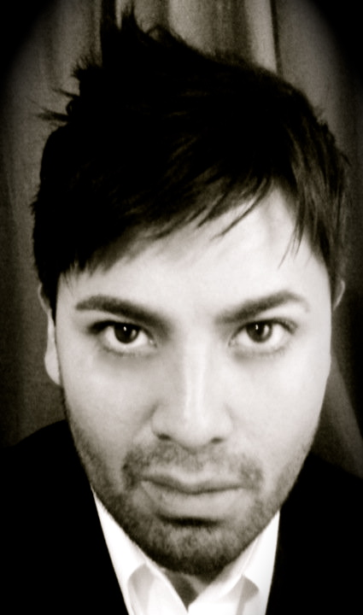
Jose Francisco Ruiz
Tenor

vocediorfeo@gmail.com
310-753-9295
New York, NY 10031
www.josefranciscoruiztenor.com

ORATORIO
Vivaldi Credo Nubian Conservatory of Music, Brooklyn 2016
Beethoven 9th Symphony Orchestra Amadeus New York 2016
Soloist Spiritual St. Catherine AME Zion Church, New Rochelle 2016
Handel Cantata no. 21 Nubian Concervatory of Music, Brooklyn 2015
Handel Cantata no. 80 Nubian Concervatory of Music, Brooklyn 2013
Stainer Crufixicion First Baptist Church, Bronxville, New York 2012
Rossini Stabat Mater (solo) St. Barnabas Episopal Church, Brooklyn 2012
Handel Israel in Egypt Nubian Conservatory of Music, Brooklyn 2011
Mozart Requiem (understudy) Nubian Conservatory of Music, Brooklyn 2010
Handel Messiah Nubian Conservatory of Music, Brooklyn 2009
Bach Cantata 96, (solo) Cantata Singers of New York 2008
Bach Cantata 106 (solo) Cantata Singers of New York 2007
Bach Semele Cantata Singers of New York 2006
Crumb Ancient Voices of Children (solo) Manhattan School of Music 2004
Beethoven 9th Symphony Westwood Presbyterian Church 2004
Handel Messiah Westwood Presbyterian Church 1997- 2004
Haydn Die Shopfung Westwood Presbyterian Church 2004
Britten Mass Westwood Presbyterian Church 2003
Bernstein Chichester Psalms(solo) Westwood Presbyterian Church 2002
Orff Carmina Burana El Camino College Chorale 1999
Mozart Regina Caeli (solo) El Camino College Chorale 1997

Services
Westwood Presbyterian Church, Westwood, California
Shilom Presbyterian Church, Brooklyn, New York
First Presbyterian Church, Greenwich Connecticut
St. Catherine AME Zion Church, New Rochelle
Park Avenue Church, New York
Berean Baptist Church, Brooklyn
Ebenzer Gospel Tabernacle, Harlem
St. Barnabas Episcopel Church, Brooklyn
Church of the Redeemer, Morristown, New Jersey
St. Brendan Catholic Church, Brooklyn

CONDUCTORS MASTER CLASS VOICE TEACHERS DICTION
Winston Voegel Carlo Pari Patricia McCaffrey Glenn Morton
Sung Jin Hong Mignon Dunn Rhonda Dillon Marianne Barrett
Kenneth Cooper Cynthia Hoffmann Christina Stanescu
David Labowitz Paul Sperry Kathryn LaBouff
Joanna Nachef
John-Kevin Hilbert SCHOOL: Manhattan School of Music, BA 2008

